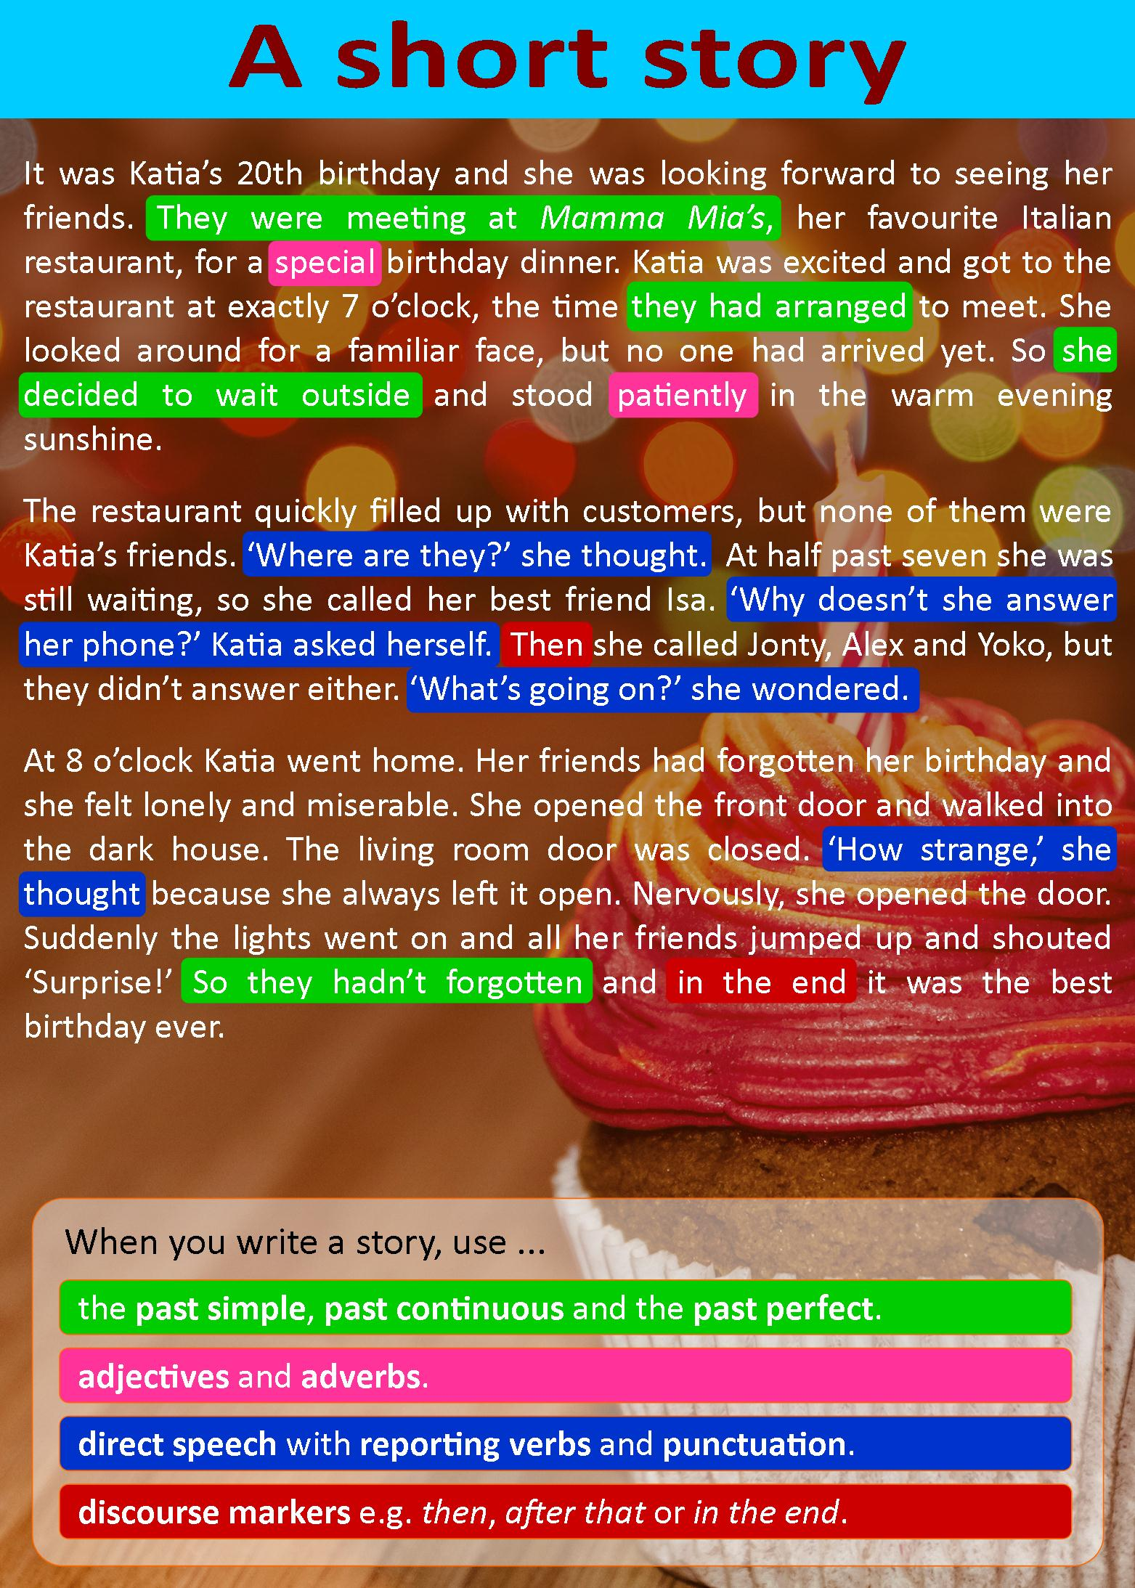

**A. Answer the following:**

1. Choose the best title for the story.

1. The accident
2. The surprise
3. My lucky day

2. Katia didn't want to celebrate her birthday.

* Principio del formulario
* True
* False

1. Final del formulario

3. Katia was the first person to arrive at the Italian restaurant.

* Principio del formulario
* True
* FalseFinal del formulario

4. Katia waited outside the restaurant for 30 minutes.

* Principio del formulario
* True
* FalseFinal del formulario

5. Jonty is Katia's closest friend.

* Principio del formulario
* True
* FalseFinal del formulario

6. Katia went home after waiting for her friends for an hour.

* Principio del formulario
* True
* FalseFinal del formulario

7. Katia's friends hadn't forgotten her birthday.

* Principio del formulario
* True
* False

**B. Match the sentences Match the sentences from the story to the correct part of the story.**

**Beginning:**

* They were meeting at Mamma Mia’s, her favorite Italian restaurant, for a special birthday dinner.

**Middle:**

* Then she called Jonty, Alex and Yoko, but they didn’t answer either. “What’s going on?” she said to herself.

**Ending:**

* Suddenly the lights went on and all her friends jumped up and shouted “Surprise!”

**Final line:**

* So they hadn’t forgotten and in the end it was the best birthday ever.

**C. Put the words in the correct group.**

enjoyable, quickly, happily, exciting, strange, freezing, awful, unexpectedly, slowly, quietly, fantastic, sadly, huge, unexpected, nervously, patiently

|  |  |
| --- | --- |
| **ADJECTIVES** | **ADVERBS** |
| enjoyable, exciting, strange, freezing, awful, fantastic, huge, unexpected | quickly, happily, unexpectedly, slowly, quietly, sadly, nervously, patiently |
|  |  |